Contents

Welcome address by the CEO 2

Mission 3

Vision 3

Consultancy on Agroveterinary Services and Food Safety 4

Training, Research and Collaboration on Agriculture and Related Sector 4

Technology and ICT Solutions in Revolutionizing Agroveterinary Practices 4

Animal Welfare 4

Stakeholders and Community Engagement on Projects 4

Climate-Smart Agriculture 4

Menu bar 4

Who we are 4

Our company: 4

Our team 5

What we do 5

Our Services 5

Our Innovations 5

Projects and trainings 6

Contact us 17

Office no. 17

Phone no. 17

Website 17

email 17

Home page

**Logo** 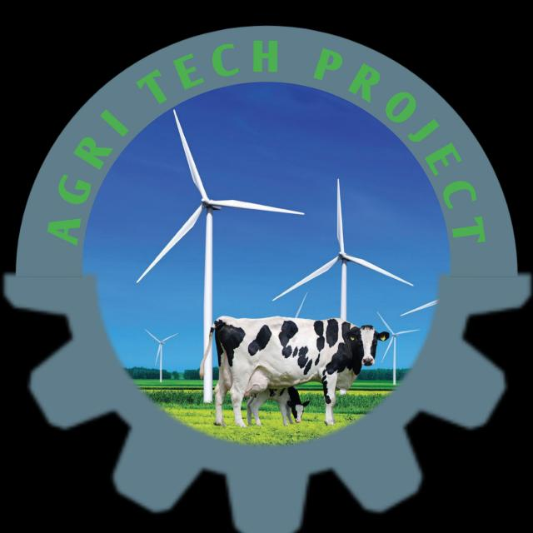

**Motto: *We Speak Agrovet Innovations Through Technology***



AGRICTECH PROJECT is a private organization established 26th of May, 2024, focusing on enhancing food safety standards while improving animal health practices, Agro-veterinary services and animal welfare through collaborative research initiatives aimed at sustainable development and bridging the gap between traditional agro-veterinary practices and modern technology by establishing strong partnerships with government agencies, NGOs, academic institutions, and private sector entities globally to achieve its objectives effectively.

**Mission**

Our mission is to revolutionize the agricultural and veterinary sectors by providing innovative consultancy services, cutting-edge technology solutions, and comprehensive training programs. We are committed to ensuring food safety, enhancing animal health and production, promoting sustainable farming practices and animal welfare. Through collaboration with national and international partners, we aim to eradicate poverty, improve public health, and drive socioeconomic development by integrating modern technology, research, Smart Agriculture to mitigate effect of climate change and stakeholder engagement into the veterinary-agriculture value chain.

**Vision**

To be a global leader in agricultural technology and consultancy, transforming the veterinary-agriculture sector into a sustainable, efficient, and welfare-driven industry. We envision a future where advanced technology, data-driven solutions, and integrated farming practices empower communities, ensure food security, and promote animal welfare, while contributing to the eradication of poverty and the prevention of foodborne diseases worldwide.

**UNITS**

Consultancy on Agro-veterinary Services and Food Safety

Training, Research and Collaboration on Agriculture and Related Sector

Technology and ICT Solutions in Revolutionizing Agro-veterinary Practices

Animal Welfare

Stakeholders and Community Engagement on Projects

Climate-Smart Agriculture

**Menu bar**

* Who we are
* Our company:

At AgriTech Project, we are dedicated to transforming agriculture and veterinary practices through innovative solutions and expertise. Our team comprises seasoned professionals, including a professor of Food Safety and Microbiology, alongside a group of passionate veterinarians, communication specialists, accounting experts and ICT experts. We offer a wide range of services including consultancy on agro-veterinary practices and food safety, training and research collaborations, and advanced ICT solutions to revolutionize the sector. Our focus extends to animal welfare, climate-smart agriculture, and empowering stakeholders through community engagement on impactful projects. With a commitment to improving food security, health, and sustainable agriculture. We work hand-in-hand with local and international partners. Our past successes include training butchers on meat hygiene, tackling antimicrobial resistance, and conducting research on farmer-herder conflicts. AgriTect Project takes pride in delivering timely, results-driven solutions that address the most pressing challenges in agricultural and veterinary sectors

Our team

Prof M.K. Lawan: Chairman and CEO

Dr Mansur Salihu: Consultancy on Agro-veterinary Services and Food Safety

Dr Suleiman Haruna: Training, Research and Collaboration on Agriculture and Related Sector.

Dr Abubakar Anas: Technology and ICT Solutions in Revolutionizing Agro-veterinary Practices.

Fatima Zahra Zubair: Animal Welfare

Rasheeda Muhammad Lawal: Stakeholders and Community Engagement on Projects and Communication Office

Prof. Yusuf Yakubu: consultant Epidemiologist and Projector coordinator

* What we do
* Our Services
* Consultancy on Agroveterinary Services and Food SafetyTraining,
* Research and Collaboration on Agriculture and Related Sector
* Technology and ICT Solutions in Revolutionizing Agroveterinary Practices
* Animal Welfare
* Stakeholders and Community Engagement on Projects
* Climate-Smart Agriculture
* Our Innovations
* Projects and trainings

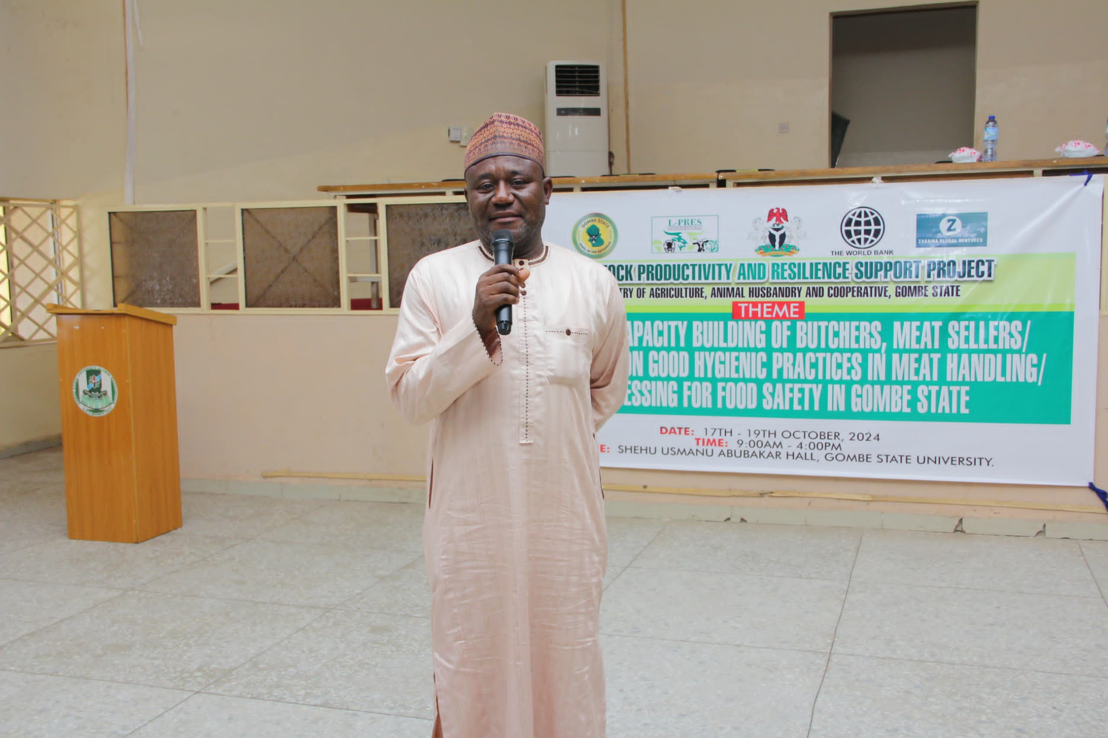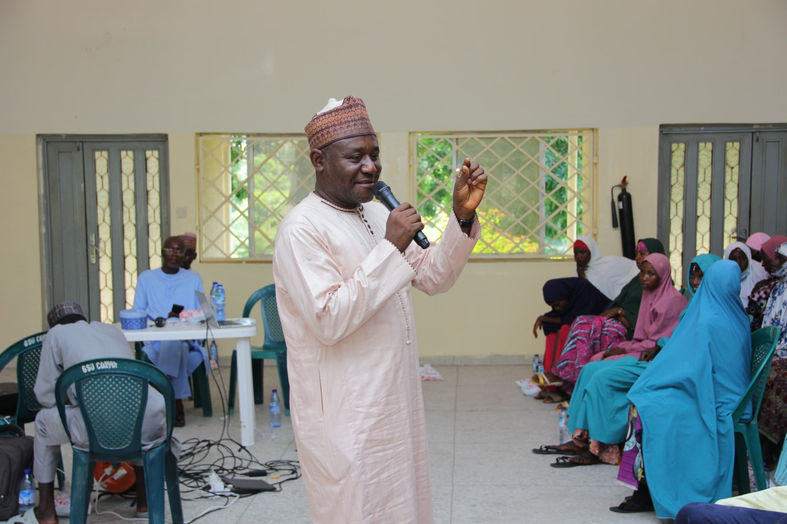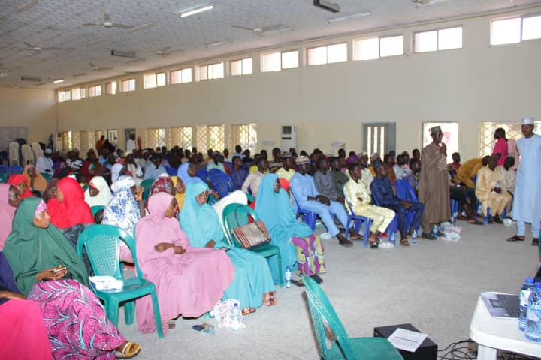

* Training of butchers and other stakeholders along meat value chains on meat hygiene in Gombe state

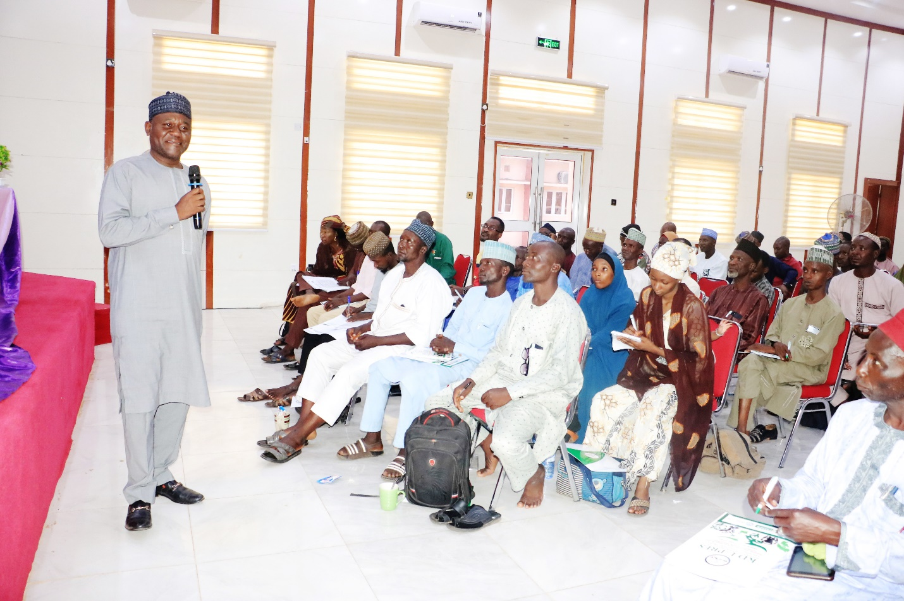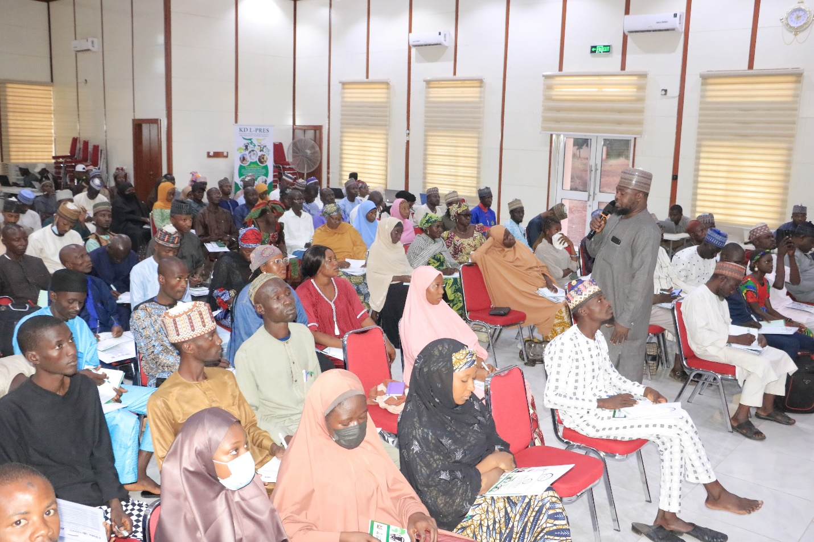

* Training of livestock owners on Antimicrobial Resistance in Kaduna State

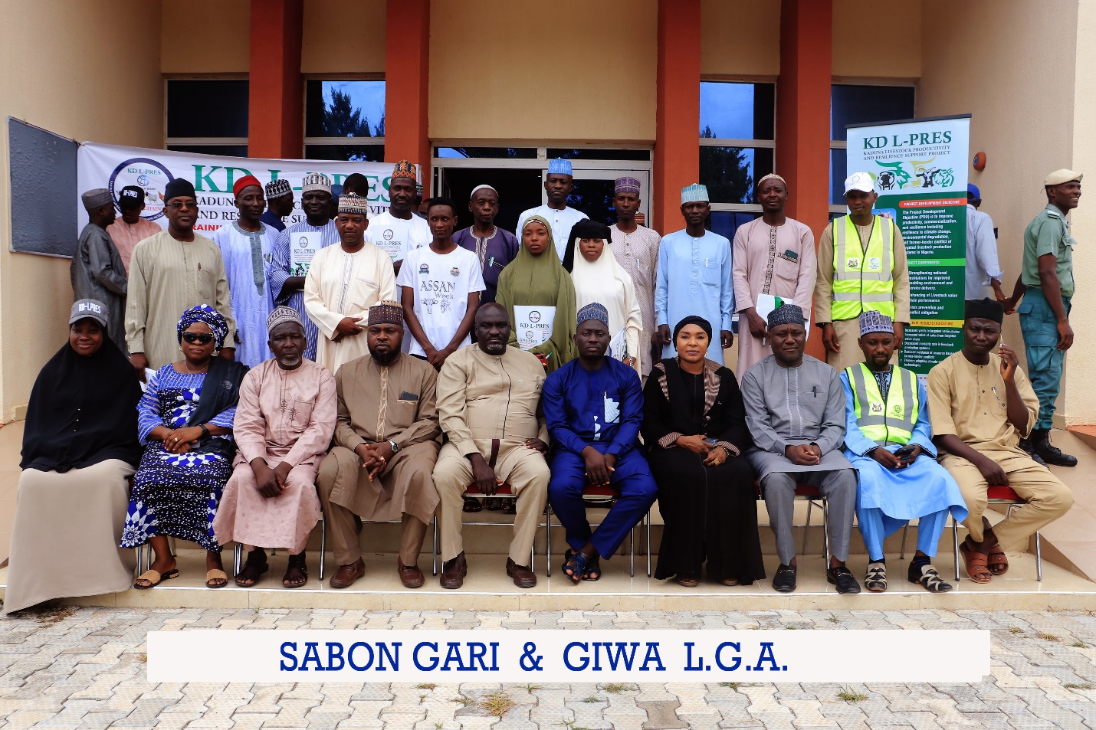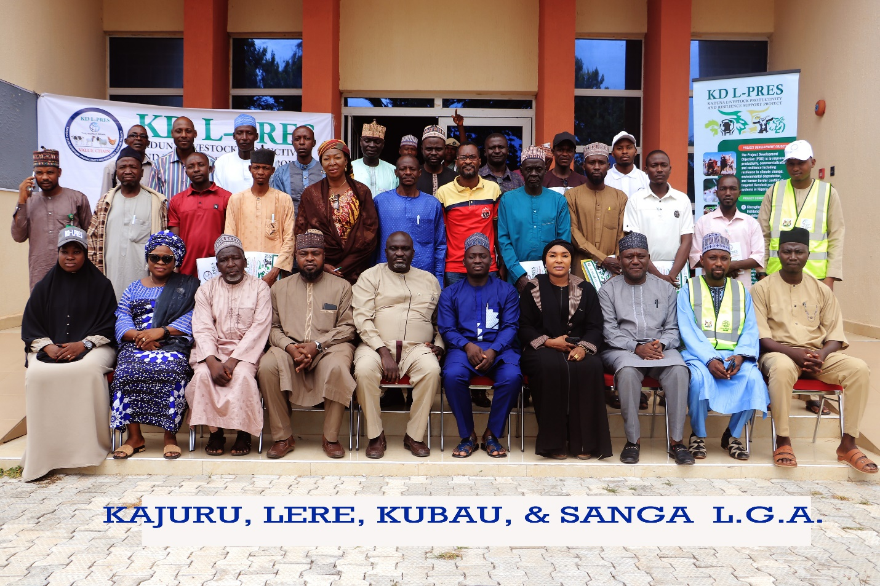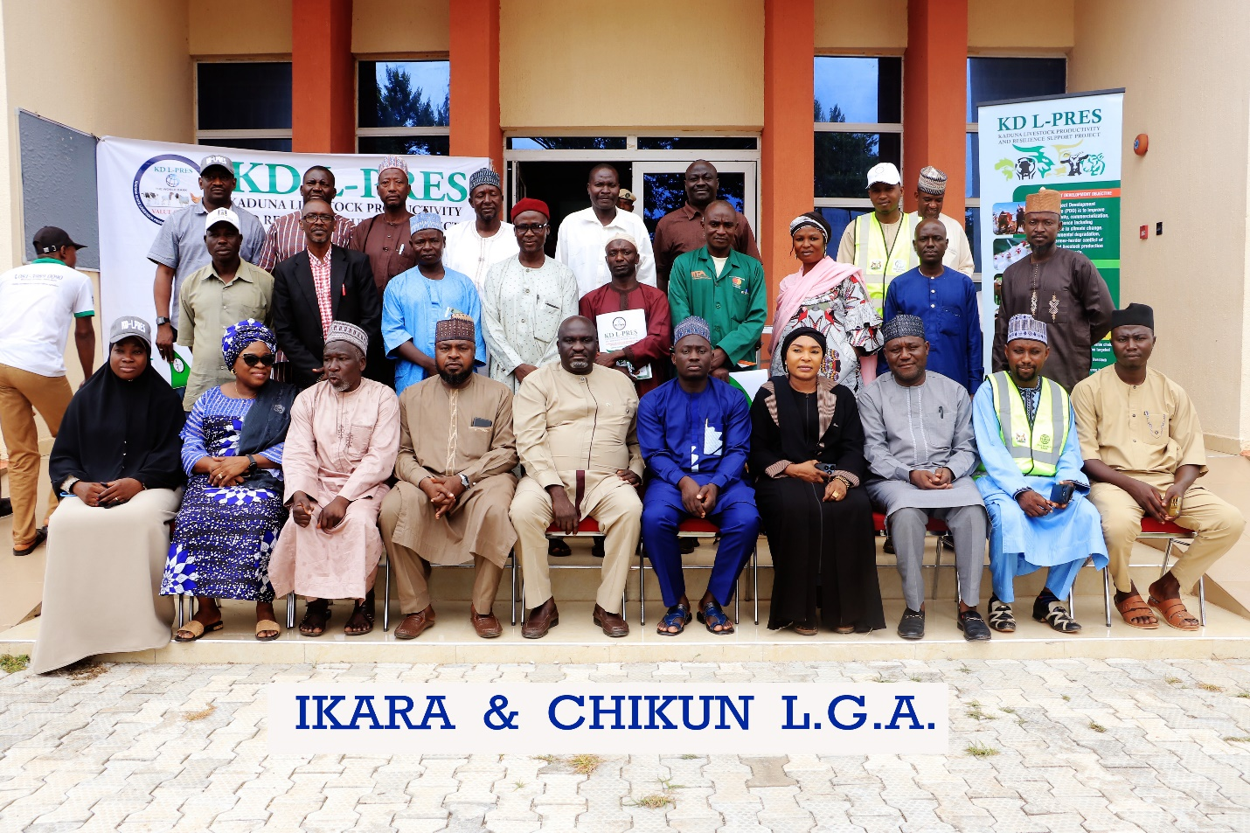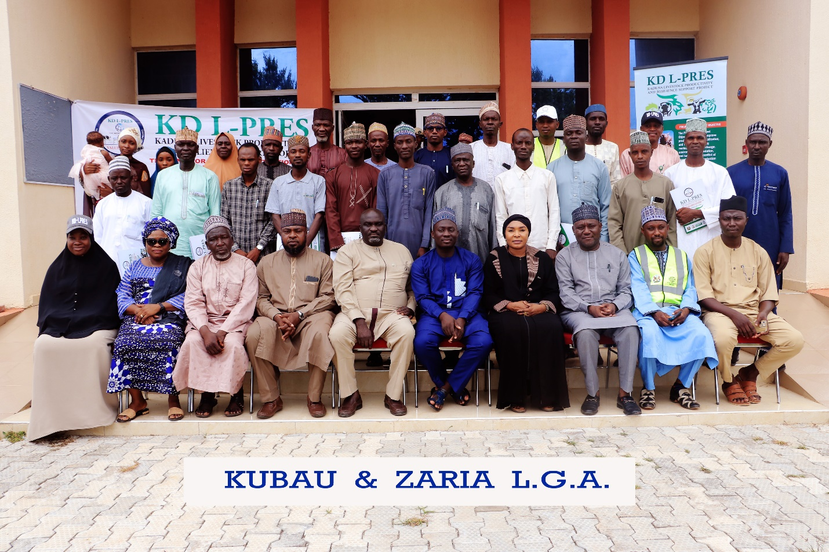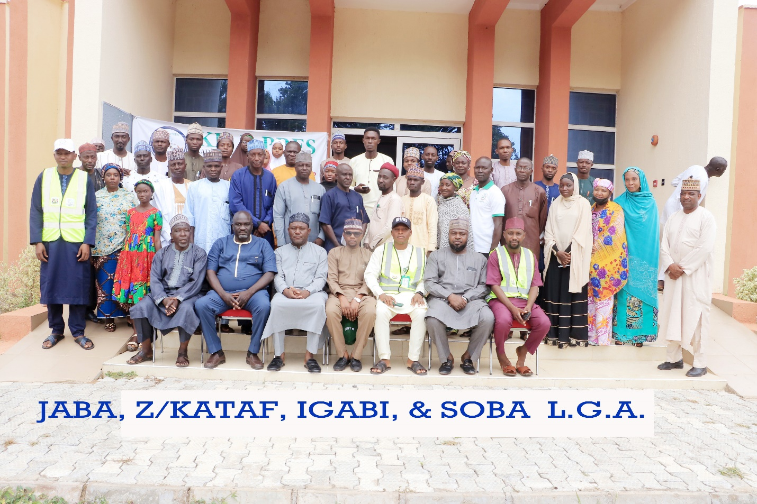

* Training of Extension workers on Animal Husbandry and equipment in Kaduna state

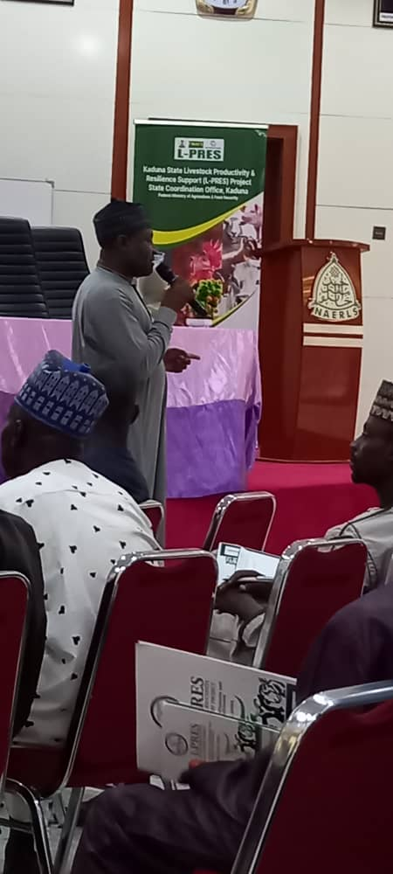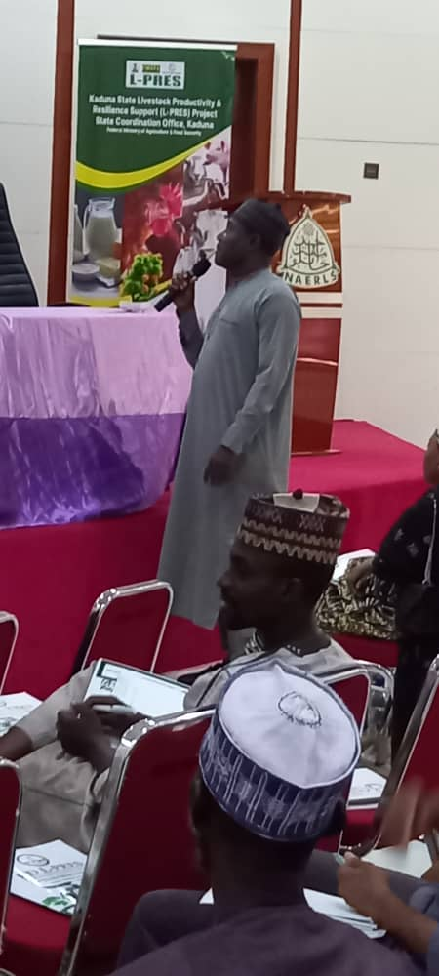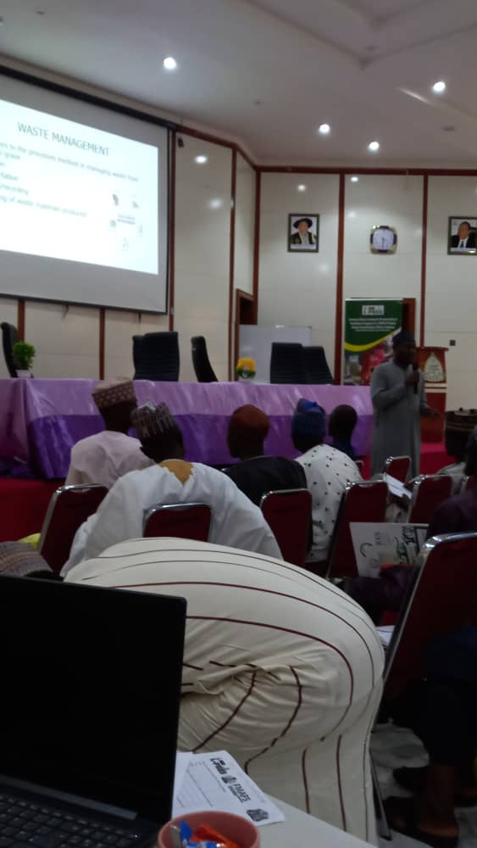

* Training of Extension workers on Waste Management and water Conservation in Kaduna state
* Contact us

Address: Office No 4, Zango shopping complex, Sokoto road Opposite Ahmadu Bello University, Silver staff Quarters, Zaria, Kaduna State Nigeria

Phone no. +2348066793019

Website

Email